**APPENDIX:**

**2)d)** MATLAB code for 3-point DFT:

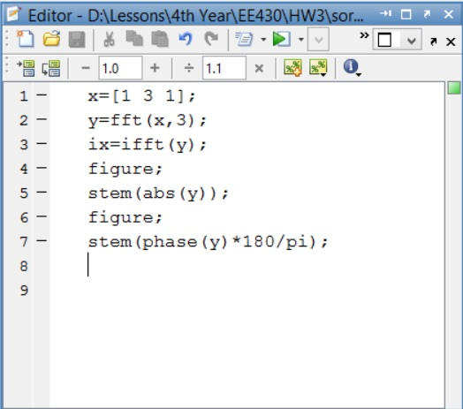

Magnitude and phase(degree) of X[k], respectively:

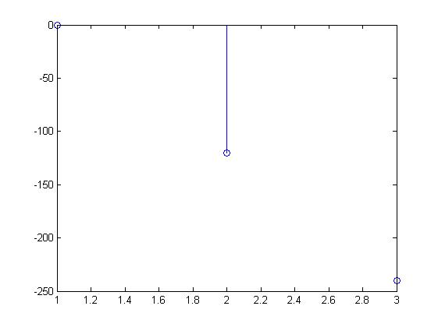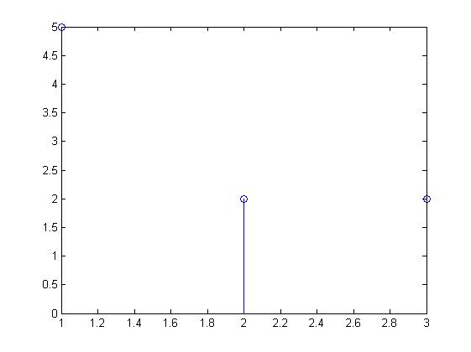

MATLAB code for 5-point DFT:

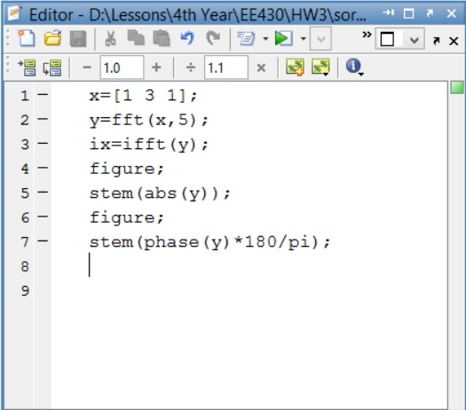

Magnitude and phase(degree) of X[k], respectively:

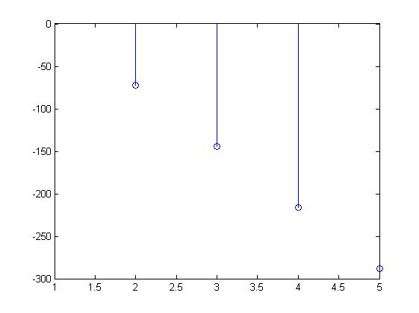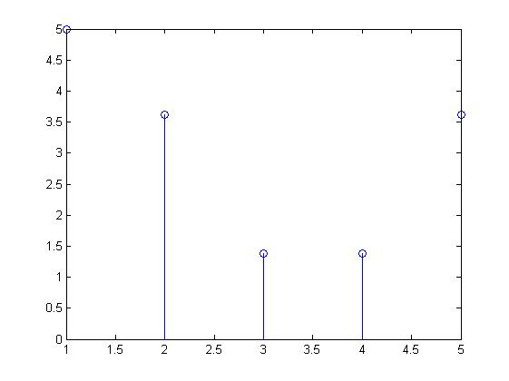

**8)c)** MATLAB code for obtaining the outputs corresponding to each input segment:

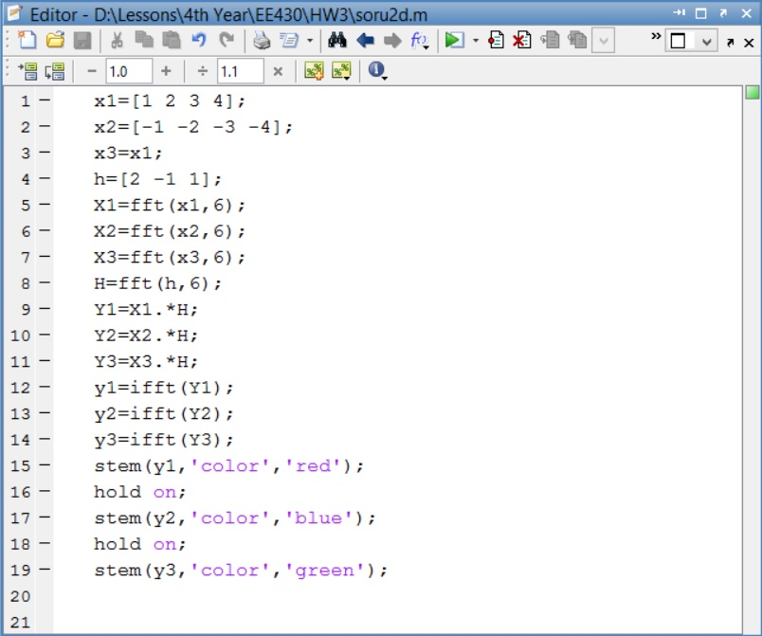

Outputs, y1 is red, y2 is green and y3 is blue: (since y1=y3 red line is not seen)

